Product Definition Document
Student motivation (NAG-25-949)
Word Count: 2600
EMMA HODKIN
202208793

Table of Contents
1. Project Background 2
1.1 Introduction 2
1.2 Objectives 2
1.2.1 Primary Objectives 2
1.2.2 Secondary Objectives 3
1.3 Scope 3
1.4 Deliverables 3
1.5 Constraints 4
1.6 Assumptions 4
2. Project Rationale 5
2.1 Project benefits 5
2.2 Project Operation 5
2.3 Options 5
2.4 Risk Analysis & Mitigation 7
2.5 Resources Required 9
2.6 Ethical & Legal Considerations 9
2.7 Commercial Considerations 9
3. Project Methodology & Outcomes 11
3.1 Initial Project Plan 11
3.1.1 Tasks and Milestones 11
3.1.2 Schedule Gantt Chart 12
3.2 Project Control 13
3.3 Project Evaluation 13
4. References 14

- Project Background

Introduction
The aim of this project is to develop an app that encourages and supports students in their studies. The primary focus of the app will be motivation, with techniques such as gamification, and organisational aids such as calendars and task lists to help students track their progress and help them build a work routine while self-studying. The project aims to provide a central source of tools and functions to aid in personal growth and academic success.

Objectives
Many students find the transition from school/A Level work (i.e. teacher-lead learning) to university style work (i.e. student-lead learning) challenging and disorienting. As such they haven’t learned which learning style is best for them (quizzing/flashcards, rewriting notes, gamification etc.) and won’t know where to start. Some students therefore become unproductive until the last few weeks where they then feel overwhelmed with their daunting task. The proposed project can show them many new techniques as well as keep them organised with their university timetable.

Primary Objectives
- Learn Authentication and Data Security skills to a useable level
  - As per GDPR (United Kingdom General Data Protection Regulation, no date), data must be kept secure and encrypted, as such learning about encryption and data hashing as well as other data security risks and mitigations will prevent user data from being mishandled or stolen
  - This will be prioritised in the Discovery phase and must be finished before development begins
  - The learned skills would then be implemented using best practices
- Gain Further skills in Backend and Server API connections
  - As the database will be hosted on a server, ensuring the application is able to connect and transfer data to and from the database will be essential.
  - These skills will be implemented when the backend is created
  - These skills will be learned during the Discovery phase before any implementation can occur
- Improve motivation of users
  - Using gamification and in-app rewards will keep users engaged in their tasks and allow users to break down their tasks into manageable sections
  - This will be measured through user testing and evaluation
  - These features will be implemented for Live phase and must have begun implementation as early as Alpha phase.
- Improve organisational skills of users
  - By combining a student’s academic and personal calendars, it would allow the user to better organise their time and availability
  - This will be measured through usability testing and the features will be tested through unit testing and the automated pipeline
  - These features will be implemented for Live phase and must have begun implementation as early as Alpha phase.

Secondary Objectives
- Improve mental health and wellbeing of users
  - This would be achieved by signposting users to university links and events for mental health and wellbeing
  - This would be tested though usability testing
  - This feature would be implemented after Live phase if sufficient time remained when it could be developed to an acceptable standard. This feature would not begin implementation until Beta phase
- Further learn skills in Design and User Interfacing
  - Using existing heuristics and colour theory to improve the app appearance and user experience
  - This would be measured using user testing and feedback
  - These skills would be prioritised during development of the frontend in Beta Phase and implemented before Live phase

Scope
The main features of the project will include a set of pre-made timers, a calendar that will show the total time worked as well as any user created events, a method of creating tasks which can be completed for points which are then collected and can be spent in the points shop. Each user will have a unique account which will be password protected, and will contain any user-created events, timers, and tasks. These features will be implemented on an Android app, with opportunity to link the user’s student timetable and canvas (Instructure, no date).
The project will not include any in-app purchases or exchanges of money, due to GDPR and FCA (FCA, no date) regulations. In addition there will only be one form of account as there is no need for admin access via accounts. As it will be an Android application, the app will not be required to also run on iOS (Apple Inc., no date). The app will not be deployed onto the app store due to hosting costs and app store requirements.

Deliverables
The main artefact will be an Android application, with a connection to a backend remote server hosted on a Virtual Machine (VM). The app will not be hosted on the app store therefore it will be a demonstration software rather than a service. The server will contain the database for the accounts, user preferences & settings, and any points the user has collected. The project will also include a full project report. The app will also use a CICD pipeline to automate unit tests and builds, as well as the app deployment.
The project will have met its objectives when it’s unit tests and user acceptance tests have been met. The user acceptance tests will assess for given heuristics and ease of movement between features, as well as usability and requirements suitability.

Constraints
The primary constraint would be the legal requirements of GDPR and data protection. Due to the laws surrounding user data and the handling of said data, strict guidelines must be followed in the collection, storage, and processing of any user data.

Assumptions
It is assumed that testing would be possible on the application, either through emulated inputs for usability testing or unit tests for functionality testing. Another assumption would be the ability to collect real user data for testing. If no user data can be obtained then dummy data would be used as a substitute.

- Project Rationale

Project benefits
New university students often struggle with maintaining a stable progression of work throughout the term. This leads to crunch at the end of term which affects the overall quality of the submission. The project encourages continuous motivation throughout the term with incentives such as earning points for submitting coursework or using the timers feature to record and track their studying. These points can then be exchanged for in-app perks which will compel the user to complete further tasks and to continue studying, causing the user to study regularly.
Students also have difficulty developing a routine with their work, balancing extracurriculars with their academic timetable and personal commitments. Having a collated calendar which can notify the user of upcoming deadlines and events will encourage the user to practice time management and help them prioritise their time. By using the timers regularly they will be able to recognise their learning style and create a routine that works within their schedule. In turn, this will reduce the chance of the user overworking themselves on busy days and underutilising their time over the course of the term.

Project Operation
This project will primarily use Agile development, augmented for a one-person group (Fryrear, no date). Using a GitHub (GitHub, Inc., no date) Project Board to track the task in the backlog, to-do, doing, done, and pen columns. GitHub Project Board will also be used to track the issues, milestones, and create the burn-up charts. Using a Project Board allows for clear visualisation of current tasks and keeps the time-based constraints clear. The project will be split into four milestones, Discovery, Alpha, Beta, and Live. Development will begin in Alpha and conclude in Live. Each milestone will consist of two 2-week sprints, with one day each for retrospectives. OneDrive (Microsoft, no date b) will be used to save iteration of the interim and final reports, as well as being uploaded to GitHub.
Each sprint will be evaluated for its effectiveness during the sprint retrospective, which runs on the first day of the next sprint. In this retrospective any unfinished tasks will be moved to the new sprint and given priority. The overall progression of work will be measured in burn-up charts, which show how many of the project’s issues were completed as well as the rate at which they were completed.

Options
IDE:
The IDE (Integrated Development Environment) is the environment in which the backend will be developed. Android Studio (Google, no date b) is an Android-specific IDE which contains many pre-built features which will be useful in the implementation phase. IntelliJ Idea (JetBrains, no date) is another IDE which could be used, however it is just a standard Java (Oracle, no date a) environment and therefore would be less suitable than Android Studio.
Database:

When storing any data, a database will be needed. Firebase (Google, no date c) contains a database feature named Firestore which uses NoSQL. MySQL (Oracle, no date b) is a database language and could also be used to create and connect the various tables in the database. However, Firestore has connections to Firebase and would easily with the Android Studio code as they are both Google products.
Framework:
Frameworks are often used for their libraries, such as tools for UI and pre-built components, which will prevent wasting time on creating components from scratch. Flutter (Google, no date d) is another Google product which already has compatibility with Android Studio and Firebase, however the framework uses Dart (Google, no date a) instead of JavaScript, as Dart is newer it has fewer libraries and has not been adopted by many services. Ionic (Ionic, no date) is another framework which also integrates with both Firebase and Android Studio and uses the much more common JavaScript.

Risk Analysis & Mitigation
Categories | Risk ID | Risk Description | Likelihood | Severity | Impact
1. Personal | 1.1 | Long Term Disruption (i.e. bereavement/ broken leg) | 2 | 5 | 10
 | 1.2 | Short Term Disruption (i.e. cold) | 2 | 3 | 6
 | 1.3 | Burnout | 3 | 3 | 9
 | 1.4 | Housing issues | 1 | 5 | 5
2. Technical | 2.1 | Laptop breaks | 2 | 5 | 10
 | 2.2 | VM is not assigned/breaks | 2 | 4 | 8
 | 2.3 | Virtual Testing Device is not working/breaks | 3 | 2 | 6
 | 2.4 | Licencing Issues | 2 | 4 | 8
 | 2.5 | Supply Chain Attack | 1 | 5 | 5
3. Project Management | 3.1 | Time Management | 4 | 4 | 16
 | 3.2 | Misinterpretation of requirements | 3 | 4 | 12
 | 3.3 | Scope creep | 3 | 3 | 9
 | 3.4 | Undefined Scope | 3 | 3 | 9
 | 3.5 | Missed Milestones | 2 | 4 | 8

Risk ID | Mitigation
1.1 | Request additional considerations and follow guidance from the university/hospital.
1.2 | Acquire appropriate medicine (e.g. cold and flu relief, lozenges, etc) and follow hygiene guidance
1.3 | Take appropriate measures to prevent burnout such as regular breaks and leisure time, if burnout occurs then rework sprints and milestones to accommodate and seek guidance from supervisor and university links
1.4 | Contact university and request additional considerations, contact housing agency or university housing for temporary accommodation
2.1 | Regularly commit to GitHub and use OneDrive when appropriate
2.2 | Apply for Azure VM if not assigned, if broken send ticket to IT and ask for estimated downtime, and change tasks/milestones as needed
2.3 | If not working for given device, choose new emulator. If broken, use personal android phone in developer mode and check with university for ethical and legal considerations
2.4 | Reduce dependency on licenced software to prevent damage to project and review changes to any software during development
2.5 | Reduce dependency on licenced software to prevent damage to project and review changes to any software during development
3.1 | Regularly check in with supervisor, regularly send work and update project board, keep and up-to-date calendar with both personal and academic deadlines and create a plan to work around them
3.2 | Create detailed, explicit requirements and review requirements regularly throughout the project to insure they are relevant and prioritised correctly
3.3 | Create a definitive list of objectives, add any new ideas to a mind-map and evaluate suitability within existing objectives
3.4 | Ensure requirements are detailed and specific, minimise ambiguity in requirements
3.5 | Ensure milestones are appropriately spaced, contain achievable and SMART goals. If milestone is missed then rework the Gantt chart and Project board to evaluate remaining time, incorporate any remaining buffer time

Resources Required
The only resource not readily available is a VM provided by the university to host the application’s server and database. This would be required at the start Alpha phase and used until deployment. If the university was unable to provide a VM then an Azure VM obtained through Azure Credits (Microsoft, no date a) could be implemented. However, an Azure VM would only be available for 12 months and would require additional funding if run for 24 hours a day. If neither option is available, then the app could be hosted locally in an undeployed state.

Ethical & Legal Considerations
User Data:
As the user will have an account and be able to manipulate the app, user data must be saved. As such, GDPR guidelines must be followed to ensure data is saved and processed lawfully and to protect the user.
Licencing:
If the project is developed commercially, the software being used may not be covered by the current licence. The appropriate licence must be obtained before any commercial development occurs.
User Feedback:
As the app will need testing and user feedback, it is essential to follow the ethical guidelines set out by the university. Any deviation from the guidelines could result in academic misconduct. Therefore, all user feedback and user testing will be structured to follow the ethics checklist.
Motivation:
Finding the balance between too much positive reinforcement and over-pressuring the user to keep studying will ensure the user keeps a positive mindset towards studying and doesn’t burn out. If the user feels pressured to study it could impact their mental health. To mitigate this the app will allow the user to toggle reminders for studying and allow them to personalise their experience.

Commercial Considerations
The project would incur several costs to undertake, if the app were published to the Google Play Store, there would be a $25 one-time registration fee (Google, no date e). Unless using a university provided VM, there will be an ongoing cost to host the database on a server. There is also the cost of labour, with a competitive salary of £14 per hour, earning £27,300 annually.
Competitors such as Todoist (Salihefendić, no date), which has a free individual licence, a $4 Pro version, and a $6 Business licence. Be Focused Pro (Ievenko, no date) has a fee of £12.99. Forest: Stay Focused (Seekrtech, no date) has no download fee, however the app contains in-app purchases and ads to mitigate their costs.
After researching similar products, a suitable price for an individual account would be a £2.99 initial charge, with the option to licence the app to an organisation such as a university and charge a subscription fee per seat. The price of the subscription would have to tally the total number of users at that organisation and multiply that by the price and compare against current costs to ensure a healthy profit margin. Another way or recuperating costs would be to introduce premium features or to make existing features premium and use either a subscription model or one-off payments for a permanent unlock.
- Project Methodology & Outcomes

Initial Project Plan

Tasks and Milestones
- The user must be able to use the accounts feature
  - The user must be able to create, update, and delete an account
  - The user must be able to log into their account
- The user must be able to use the Timers feature
  - The user must be able to use and edit the premade timers
  - The user must be able to create their own timers
  - The timers must be saved onto the user’s account
  - The user must be able to delete any timer on their account (premade or self-made)
- The user must be able to manipulate the calendar feature
  - The users must be able to add, edit, and delete events from the calendar
  - The calendar must show the total hours worked that day, and each study session
    - This must be shown as individual sessions timed either by the in-app timers or by user input
    - Each day will reset at midnight, in a given time-zone. If a session crosses over through midnight the app will record the session on the day the session was started
  - The user should be able to integrate their university timetable with the calendar feature
- The user must be able to collect points
  - The points must be given upon completion of a given task added to the calendar
  - The points gained must increase if a task is completed before the given date
  - No points must be given if a task is not completed by the given date
  - The user must be able to use those points in a cosmetics shop on the app
Task ID | Sprint | Milestone
1.1 | 1 | Alpha
1.2 | 1 | Alpha
2.1 | 1 | Alpha
2.2 | 3 | Beta
2.3 | 3 | Beta
2.4 | 2 | Alpha
3.1 | 2 | Alpha
3.2 | 4 | Beta
3.2.1 | 4 | Beta
3.2.2 | 4 | Beta
3.3 | 6 | Live
4.1 | 2 | Alpha
4.2 | 5 | Live
4.3 | 5 | Live
4.4 | 6 | Live

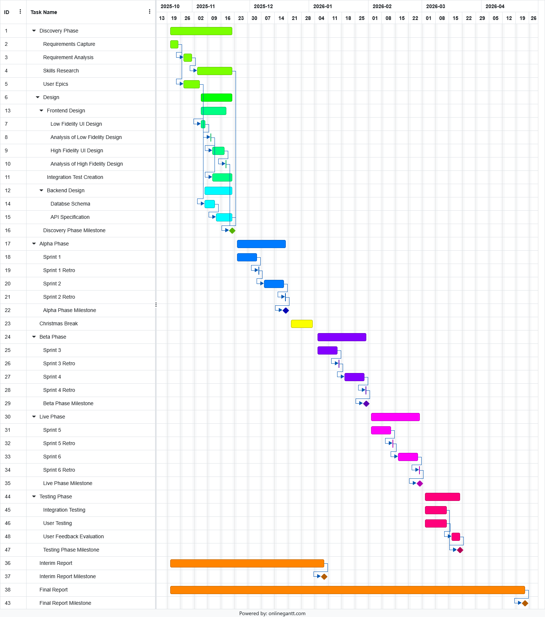
Schedule Gantt Chart

Project Control
As the project will be conducted using Agile techniques, there will be daily Scrum meetings to assess what tasks can be moved to the ‘done’ column, what can be added to the day’s ‘To-Do’ column, and if there are ay new tasks which need to be added to the project ‘Backlog’. As the Project Board is connected to the GitHub repository, each time the Project Board is updates, the GitHub repo is also updated, ensuring the project is always up to date.

Project Evaluation
Success of the project will be determined using user feedback, automated unit tests, and burn-up charts. User feedback will be obtained during the discovery and testing phases, with UIUX testing in the discovery phase by using cognitive walkthroughs in prototype, and testing after live phase in the deployed application. The application will include unit tests which will be run using a CICD pipeline upon building the project to test functionality. The Agile aspect of the project will be monitored through the use of burn-up charts to track progress and distribution of effort over each sprint.
- References
Apple Inc. (no date) OS - iOS 26 - Apple (UK). https://www.apple.com/uk/os/ios/ [Accessed 16 Oct 2025].
FCA (no date) Financial Conduct Authority | FCA. https://www.fca.org.uk/ [Accessed 15 Oct 2025].
Fryrear, A. (no date) Going Agile On Your Own. https://www.agilesherpas.com/blog/going-agile-alone [Accessed 15 Oct 2025].
GitHub, Inc. (no date) About GitHub. https://github.com/about [Accessed 15 Oct 2025].
Google (no date a) Dart programming language. https://dart.dev/ [Accessed 16 Oct 2025].
Google (no date b) Download Android Studio & App Tools - Android Developers. https://developer.android.com/studio [Accessed 15 Oct 2025].
Google (no date c) Firebase | Google’s Mobile and Web App Development Platform. https://firebase.google.com/ [Accessed 15 Oct 2025].
Google (no date d) Flutter - Build apps for any screen. https://flutter.dev/ [Accessed 15 Oct 2025].
Google (no date e) Get started with Play Console - Play Console Help. https://support.google.com/googleplay/android-developer/answer/6112435?hl=en#zippy= [Accessed 16 Oct 2025].
Ievenko, D. (no date) Be Focused Pro - Focus Timer on the App Store. https://apps.apple.com/us/app/be-focused-pro-focus-timer/id953426154 [Accessed 15 Oct 2025].
Instructure (no date) Canvas. https://www.instructure.com/en-gb/canvas/ [Accessed 15 Oct 2025].
Ionic (no date) Ionic Framework - The Cross-Platform App Development Leader. https://ionicframework.com/ [Accessed 15 Oct 2025].
JetBrains (no date) The Leading IDE for Professional Java and Kotlin Development. https://www.jetbrains.com/idea/ [Accessed 15 Oct 2025].
Microsoft (no date a) Azure for Students – Free Account Credit | Microsoft Azure. https://azure.microsoft.com/en-us/free/students [Accessed 15 Oct 2025].
Microsoft (no date b) Personal File Sharing & Cloud Storage | Microsoft OneDrive. https://www.microsoft.com/en-gb/microsoft-365/onedrive/online-cloud-storage [Accessed 15 Oct 2025].
Oracle (no date a) Java | Oracle. https://www.java.com/en/ [Accessed 15 Oct 2025].
Oracle (no date b) MySQL. https://www.mysql.com/ [Accessed 15 Oct 2025].
Salihefendić, A. (no date) Todoist | RoundPie Docs. https://docs.rpie.me/inbound-integrations/todoist [Accessed 15 Oct 2025].
Seekrtech (no date) Forest - Stay focused, be present. https://www.forestapp.cc/ [Accessed 15 Oct 2025].
United Kingdom General Data Protection Regulation (no date) Https://Webarchive.Nationalarchives.Gov.Uk/Eu-Exit/Https://Eur-Lex.Europa.Eu/Legal-Content/EN/TXT/?uri=CELEX:02016R0679-20160504. King’s Printer of Acts of Parliament. https://www.legislation.gov.uk/eur/2016/679/article/5 [Accessed 2 Oct 2025].

